**PROJECT REPORT ON**

**EMPLOYEE MANAGEMENT SYSTEM USING SPRING FRAMEWORK AND RESTFUL API**

Submitted in partial fulfillment of the requirements for the degree of

**BACHELOR OF TECHNOLOGY IN**

**COMPUTER SCIENCE AND ENGINEERING**

**OF SASTRA UNIVERSITY**

**Submitted by**

**Kuna Praneetha(117003102)**



**Under the Guidance of**

**B.Ramasubramanian**

**i|Nautix Technologies-A BNY Mellon Company CHENNAI**

**SCHOOL OF COMPUTING**

**SHANMUGHA**

**ARTS, SCIENCE, TECHNOLOGY & RESEARCH ACADEMY**

**(SASTRA UNIVERSITY)**

**(A University Established under section 3 of the UGC Act, 1956)**

**TIRUMALAISAMUDRAM**

**THANJAVUR – 613 401**

**April 2017**

**SCHOOL OF COMPUTING**

**SHANMUGHA**

**ARTS, SCIENCE, TECHNOLOGY & RESEARCH ACADEMY**

**(SASTRA UNIVERSITY)**

**(A University Established under section 3 of the UGC Act, 1956)**

**TIRUMALAISAMUDRAM, THANJAVUR – 613401**



**BONAFIDE CERTIFICATE**

Certified that this project work entitled “Employee Management System using Spring Framework And Restful API” submitted to the Shanmugha Arts, Science, Technology & Research Academy (SASTRA University), Tirumalaisamudram- 613401 by

**Kuna.Praneetha with 117003102**

in partial fulfillment of the requirement for the award of the degree of **BACHELOR OF TECHNOLOGY IN COMPUTER** **SCIENCE AND ENGINEERING** is the original and independent work carried out under my guidance, during the period January2017 - April 2017**.**

|  |  |
| --- | --- |
| **INTERNAL GUIDE** | **ASSOCIATE DEAN** |
| **B.RAMASUBRAMANIAN,** | **Dr. A. UMAMAKESWARI** |
| **i|Nautix Technologies-A BNY Mellon Compnay,Chennai** | **SCHOOL OF COMPUTING** |

Submitted for University Examination held on___________________

**EXAMINER - I** **EXAMINER - II**

**SCHOOL OF COMPUTING**

**SHANMUGHA**

**ARTS, SCIENCE, TECHNOLOGY & RESEARCH ACADEMY**

**(SASTRA UNIVERSITY)**

**(A University Established under section 3 of the UGC Act, 1956)**

**TIRUMALAISAMUDRAM, THANJAVUR – 613401**



**DECLARATION**

We submit this project work entitled **“EMPLOYEE MANAGEMENT SYSTEM USING SPRING FRAMEWORK AND RESTFUL API”** to the Shanmugha Arts, Science, Technology & Research Academy (SASTRA) University, Tirumalaisamudram–613 401, in partial fulfillment of the requirement for the award of the degree of **BACHELOR OF TECHNOLOGY IN COMPUTER SCIENCE AND ENGINEERING** and declare that it is our original and independent work carried out under the guidance of Mr. **B.Ramasubramanian,i|Nautix Technologies-A BNY Mellon Company.**

**Date: 03/4/2017 Name: Kuna Praneetha Signature:**

**Place: Chennai Reg. No: 117003102**

**ACKNOWLEDGEMENT**

It is a great pleasure for us to present this project to all of you. We would like to acknowledge each and every one who had a role to play in making our humble efforts an out-to-out success.

We would like to thank our Honorable **Vice Chancellor (Col.) R. Sethuraman** for providing us with an opportunity and the necessary infrastructure for carrying out this project as a part of our curriculum.

We find very heartening the encouragement and strategic support offered at every step of our college life by **Dr. S. Vaidhyasubramaniam**, **Dean, Planning & Development** and **Dr. V. Badrinath, Dean, Training & Placement and School of Management** and for that we would like to thank them time and again.

We wish to express our gratitude to **Dr. A Umamakeswari**, **Associate Dean**, **and School of computing** for her foresight and guidance, to complete our project in time.

We extend our heartfelt thanks to the **Registrar**, **Dr. G. Bhalachandran**, for providing the opportunity to pursuit this project.

We are very thankful to our internal guide **B.Ramasubramanian**,i|Nautix Technologies, for encouragement, guidance and support throughout the project.

We express our sincere thanks to all the staff of School of computing, for the help throughout the project.

We express our wholehearted gratitude to our parents and friends who kept my spirits high without whose cooperation the completion of the project would not be possible.

**TABLE OF CONTENTS:**

|  |  |  |
| --- | --- | --- |
| **S. no.** | **CHAPTER** | **Page Number** |
| **1** | **Introduction** | **1** |
| **2** | **Statement of the Problem** | **3** |
| **3** | **Objectives of the study** | **5** |
| **4** | **Literature Review** | **6** |
| **5** | **Software, Hardware Requirement Specification** | **8** |
| **6** | **Conceptual Modeling** | **10** |
| **7** | **Interaction Scenario** | **13** |
| **8** | **Methodology and Approach** | **15** |
| **9** | **Output** | **21** |
| **10** | **Steps to develop application** | **27** |
| **11** | **Advance Rest Controller** | **30** |
| **12** | **Conclusion** | **34** |
| **13** | **References** | **35** |

**1. INTRODUCTION**

**1.1 About the Company**

i|Nautix Technologies India Private Limited located in Chennai and Pune in India, is a group company of Bank of New York Mellon-leading financial services provider. The Bank of New York is the top most and oldest banking corporation in the United States, and it is the 20th-oldest bank in the world, which have been established on June 9, 1784, by American Founding Father Alexander Hamilton.

i|Nautix provide technology development, business and technology operations and remote infrastructure management services for BNY Mellon and its subsidiaries. It also develops and delivers wide ranging technology solutions and products for customers of Bank Of New York Mellon..i|Nautix is a vital arm of Client Technology Solutions at Bank Of New York Mellon.

i|Nautix provides the following:

* Deliver service excellence and innovative solutions.
* Encourage the development of a collaborative work environment that values inclusion and offers associates, opportunity for growth and recognition.
* Deliver insights in shaping the future of our industry.
* Support local and global communities.

i|Nautix provides Cutting Edge Technology Services,Application performance,availability,response times are important factors for success in evolving the competitive capital field markets. i|Nautix have a expertise in building a wide array of financial systems which includes

1. broker customer management platform,
2. asset movement systems,
3. back office processing systems,
4. advisor platforms,
5. retail client platforms and
6. institutional platforms

i|Nautix combines technical expertness with agility, experience,value,integrity and flexibility to deliver wide ranging technological solutions. To ensure a prompt service response in today's rapidly changing market situations, the entire i|Nautix team works as a unified whole from beginning to finish by combine their extensive domain experience and technology expertise to provide a acceptable range of service offerings like Production Validation Services, Full Life Cycle Application Development, Human Factors Engineering etc.

**Company Technologies**

***Nexen Gateway:***

BNY Mellon has always been at the leading of innovation, leading the way with new thinking as well as products and services designed to help our clients succeed.

From cloud computing to mobile platforms to big data technologies and more, BNY Mellon are creating a new way of developing and delivering solutions to clients and focusing on increasing access and collaboration in the markets, improving reliability, flexibility and efficiency, for building stronger risk management and facilitating growth through access to value-added information-based services.

BNY Mellon is launching the biggest technological transformation which is NEXENSM, a new open-source, cloud-based technology platform. NEXEN has been designed to empower clients to change the way they operate which is more flexible, client-responsive, efficient and fast. Its cutting edge technology will help clients at every stage of the investment lifecycle.

The main objective of i|Nautix is to create new and original solutions that will position our clients for success which include:

* **Cloud-based platform** – NEXEN, is a new open-source cloud-based technology platform, which is on the cutting-edge of financial services.
* **Big Data Insights** – Digital Pulse, Digital Workplace provides data-driven insights to make evidence-based decisions faster.
* **Acquisition Strategy** – Power of advanced investment technology from BNY Mellon acquisitions like AlbridgeTM, Eagle and Hedgemark.
* **Innovation Centers** – Bank of New York Mellon new Innovation centers in Silicon Valley,Chennai,Pune maintain close contact with leading thinkers, new talent and open source culture.

**1.2 BACKGROUND OF THE PROJECT**

Employee management is the management of mates in an organization. Often, large organizations have many of these functions performed by a specialist department, such as Personnel or Human Resources, but managers are still required to supervise and administer the activities of the employees under them, and ensure the well-being, of the employee that report to them.

Most of the modern Information systems are based on the Database technology, as a collection of related data, and Database Management System as a software system allowing the users to define, create, maintain and control access to the database. The process of implementing such kind of systems is not so simple. It involves mutual development of application program which is the role of developer and database. The application program is, actually the interface between the users and the database, where the data is stored. Thus, a well-developed application program and database are very important for the reliability, flexibility and functionality of the system.

The basic idea can be depicted on Figure below:

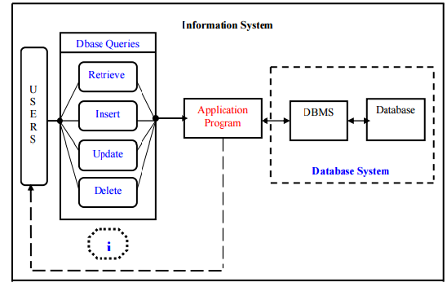

Employee management system suggests advanced technology to be used in order to provide the information to employees in an organization , for the purposes of data transformation into useful information, computer hardware and software are designed and used .

A particular case is that the Human Resources Information System development. This type of systems are responsible for storing data of the employee within an organization and generating reports upon request. Such kind of system could be integrated with other modules like

* Accounting Information System(AIS)-designed to transform financial data information or

* Management Information System (MIS) that provides decision-oriented information to managers, etc…

Organizations depend on Information Systems in order to stay competitive in a present day market. Productivity, which is crucial factor for staying competitive, can be increased through better Information Systems.

The End users can insert, delete, update and retrieve the data from the database. The Application program acts as a interface between the database and the user.

**2. PROBLEM STATEMENT**

Management of employee information is very crucial to any organization and it is very important to every organization to have their employee detail record stored. This makes the company very easy to browse about the current employee regarding the ID, place, age and address etc.

Previously the data of the employees was maintained in a spreadsheet format but maintaining the data in a spreadsheet format will make the date vulnerable to human errors. And such applications would be not fast and efficient in retrieving the data. Hence so after the databases were developed the work became much simpler for retrieving, inserting any information about the employee of the organization

This system makes the process of scheduling much easier and computerized. By this system the manager or higher level designated employee can view the details of any employee working under him, he even can check whether the employee is free in the particular time or in other times. Thus the higher designation management can easily fix the process of scheduling, and also can change the appointment which is reflected immediately to the related employee avoiding direct contact of the employee resulting in saving lot of time and work overhead.

**3. OBJECTIVE**

The objectives of the system are:

This application will reduce the complexity of employee management.

By using this system one can easily maintain all the records about all the employees of the organization

It will reduce the time to search any record of an employee.

It is easy to handle by any person who have elementary and basic knowledge of computer as it provides an user friendly environment.

**3.1 The Domain**

Employee Management System is one in which it is easy and simpler to maintain the information regarding an employee like the name, year of joining, projects etc. The traditional way of maintaining the details of an employee gets complicated when there is a lot of information to be updated often.

**3.2 Existing System**

. The Existing System is a tightly coupled java application. The Existing System uses servlets and java server page(JSP) technologies for accessing the data from the database. In case of any enhancements the entire code needs to be modified which is a time consuming process. As it is time consuming process, the existing system has been yet to be developed using spring framework and Restful API web services.

**3.3 Proposed System**

The application has been replaced with an interface much better to use and also matching with the current trends. User experience part has been increased with additional options to update any details and view any details of any employee. As the proposed system uses Spring technology and if any enhancement is required in the code it can be done just by changing the bean class.Thus it had reduced the complexity and its not time consuming.

**4. LITERATURE REVIEW**

This application for managing the employee information uses Java for the server side code and the back end, HTML,CSS for user interface, servlets and jsp for connecting to the database and thus developed a tightly coupled java application. Spring framework and Restful API were used to enhance this application to a loosely coupled.

**4.1 Eclipse**

Eclipse is an open source platform that helps a software developer to create a customized development environment (IDE) from plug-in components built by Eclipse members. Eclipse provides a program (UI) model for operating with tools.  It is designed to run on multiple operating systems while providing robust integration with each underlying OS.  Plug-ins can program to the Eclipse portable APIs and run unchanged on any of the supported operating systems

**4.2Oracle Sql**

Oracle SQL Developer is an integrated development tool that simplifies the development and management of  Oracle Database in traditional and Cloud deployments. SQL Developer offers complete end-to-end development of  applications, a worksheet for running queries and scripts, a DBA console for managing the database, a report interface, a complete data modeling solution , and a migration platform for moving your 3rd party databases to Oracle. Oracle Sql database has been used to store the details of the employee and it does the process of inserting, retrieving and updating the records of an employee. Oracle SQL provides an easy, elegant, performant architecture for accessing, defining, and maintaining data.

**4.3Spring**

The Spring Framework is a lightweight for building enterprise-ready applications. However, Spring is modular, allowing to use only those parts that are needed, without having to bring in the rest. One can use the IOC container, with any web framework on top, but can also use only the [Hibernate integration code](https://docs.spring.io/spring/docs/current/spring-framework-reference/htmlsingle/#orm-hibernate) or the [JDBC abstraction layer](https://docs.spring.io/spring/docs/current/spring-framework-reference/htmlsingle/#jdbc-introduction). The Spring Framework supports transaction management and remote access to your logic through web services, and various options for persisting your data. It offers a full-featured [ModelViewController (MVC) framework](https://docs.spring.io/spring/docs/current/spring-framework-reference/htmlsingle/#mvc-introduction), and enables you to integrate [AOP](https://docs.spring.io/spring/docs/current/spring-framework-reference/htmlsingle/#aop-introduction) transparently into your software. The Spring Framework is a Java platform that provides comprehensive infrastructure support for developing Java applications. Spring handles the infrastructure so one can focus on application

**4.4Restful API**

Representational state transfer (REST) or RESTful [Web services](https://en.wikipedia.org/wiki/Web_service) are one of the way which provides interface between computer systems on the [Internet](https://en.wikipedia.org/wiki/Internet). REST-compliant Web services allows the requesting systems to access and manipulate textual representations of [Web sources](https://en.wikipedia.org/wiki/Web_resource) using a uniform and predefined set of [stateless](https://en.wikipedia.org/wiki/Stateless_protocol) operations. Other forms of Web service also exist, which expose their own kind of arbitrary sets of operations such as [WSDL](https://en.wikipedia.org/wiki/WSDL) and [SOAP](https://en.wikipedia.org/wiki/SOAP). In a RESTful Web service, requests made to a resource's [URI](https://en.wikipedia.org/wiki/URI) will draw a response that may be in [XML](https://en.wikipedia.org/wiki/XML), [HTML](https://en.wikipedia.org/wiki/HTML), [JSON](https://en.wikipedia.org/wiki/JSON) or some other predefined format. The response body may confirm that some alteration has been made to the already stored resource, and it may provide some [hypertext](https://en.wikipedia.org/wiki/Hypertext) links to other resources which are related or collections of resources. Using [HTTP](https://en.wikipedia.org/wiki/HTTP), which is most common, the type of operations available which are predefined by the [HTTP verbs](https://en.wikipedia.org/wiki/HTTP_verbs) are  GET, POST, PUT, DELETE etc. By using stateless protocols REST systems aim for fast performance, reliability and flexibility and by re-using components that can be managed and updated without affecting the system as a whole, even while it is running.

**5. SOFTWARE REQUIREMENT SPECIFICATION**

**5.1 Software requirements**

The following are the minimum requirements that the target system (Employee Management System) is expected to satisfy for smooth running of this application.

Operating System: Windows 2007 or above

Eclipse: 3.4 or greater

HTML 5

CSS 3

**5.2 Hardware Requirements**

The following are the minimum hardware requirements that the target system is expected to satisfy for running this program.

Processor: 1 GHz or Higher

RAM: 1GB or higher

Storage Space: 50MB free space

**5.3 Development Specifications**

Technologies used: Java (Eclipse), Spring

IDE used: Eclipse,Maven Platform

**5.4 Functional requirements**

The following functional requirements were specified

* The application checks if the entered employee number and PIN are valid.
* The application will allow the Employees to view the projects submitted by them and also the list of on going projects and can also view the points the employee earned.
* This application allows the manager or top level designated employee can view the details of any employee working under him, he even can check whether the employee is free in particular time or in other times

**5.5 NON FUNCTIONAL REQUREMENTS**

**5.5.1 Performance requirements**

The user should be able know the next step in the process with certain prompts. This makes the application user friendly. Care should be taken as to observe that no column is filled with erroneous or ghost data. While signing up to the application So the tool should make the user application can be used for easy and faster usage..

**5.5.2 Operational Requirements**

The application should be ready to be deployed in other applications with limited and easy customizations. Such as able to run on any browser and data and can be integrated as a component or plug-in. This makes the application that is to be developed behave as a component in the real world.

**5.5.3Alert Messages**

The user should know the process and must be alerted with accurate error messages and the error codes must be decoded or translated in such a way that the user should know what exactly the error is and what is supposed to be done by the user for the process to be completed successfully.

**6. CONCEPTUAL MODELLING**

**6.1 Use-Case Diagram:**



*Figure 6.1. Use case diagram for various users*

**6.2 Class Diagram**



*Figure 6.2 Class diagram*

**6.3 Activity Diagram**

*Figure* 6.3 *Activity Diagram*

**7. INTERACTION SCENARIO**

**7.1 Sequence Diagram**



*Figure 7.1. Sequence Diagram for All Users*



*Figure 7.2. Sequence Diagram for Checking performance*



*Figure 7.3 Sequence Diagram for any Feedbacks & Suggestion*

**8. METHODOLOGIES AND APPROACH**

**8.1 Design**

**8.1.1 Client-Side Design**

The user interface is kept simple and understandable. The user need not take any additional effort to understand the functionality and navigation in the application. The layouts are chosen in such a way that user can easily understand where the input has to be given. Non mandatory fields are mentioned with required descriptions to help the user in giving the correct input.

The following are the main screens and features in this application.

* Home screen
* Employee interface screen
* Signup Screen

**Home screen:**  
 This is the first screen that any user is greeted with. It is used to do two things:

* **“Employee ID”:** To enter the ID of the Employee
* **“Password”:** To enter the password of the particular ID
* **“Submit” Button:** To transit to the next page.
* **“Forgot Password”:** To regenerate the password
* **“Sign Up”:** Any new Employee can register.

**Employee interface screen:**

This is the second screen that allows Employee to view his details. This screen has the following sections:

* Profile
* Projects
* Performance
* Payments
* Contact details
* Change Password
* Logout
* **“Profile”:** On clicking this tab the employee can view his details like name, employee ID, designation etc.
* **“Projects”:** This tab navigates to the Project Details where he can view the ongoing projects and the completed projects.
* **“Performance”:** On clicking the following tab the employee can view the number of working hours ,extra working hours, the points he scored like wow points and jira points.
* **“Payroll”:** On clicking the following tab it gives all the details about the salary like the basic pay, DA, EIS etc.
* **“Contact Details”:** This tab helps to view the details like the desk number, the VoIP, email-id etc.
* **“Logout”:** This tab provides the functionality of signing out of the application.

The employee interface screen have an extra tab named as “View Peers”, this tab will be provide only to the employees of higher designation like HR Manager,Manager,Project Leads etc.

**-“View Peers”**: This tab helps the manager to view the details of an employee working under him/her.

**Signup Screen:**  
  This screen displays the necessary details required to be filled by any new employee of the organization to get registered with the website. The Screen has the following columns:

* First Name
* Last Name
* DateofBirth
* Gender
* Password
* Reenter Password
* Designation
* Personal Email-id
* Contact
* Security Question
* Answer

The new employee of the organization should provide all the following details to get registered with the website.

* **“Submit Button”:** By clicking the submit button, all the details of the employee will be stored in the database and a employee id will be assigned.
* **“Reset Button”:** The reset button helps the employee to reset the details given by him.

  .

**8.1.2 Server-Side Design**

**Activities:**

* Storing the details of the new employee when he gets signed up.
* Generating the employee ID and organization email to the employee.
* Storing the updated information of the employee

**Storing the details of the new employee when he gets signed up.**

Once the new employee enters all the information which is required for registering to the application and on clicking the submit button on the signup screen the mandatory fields are checked, if not empty the field’s values are retrieved and stored in their corresponding variables on the server side and if empty and error dialog is shown to check the mandatory fields.

**Generating the employee ID and organization email to the employee.**

After the submission of details by the employee unique ID, official email will be given to the employee. The employee can logon to the application with that id and password. And also can check all the mails within the organization with email provided to him. The application helps the employee to view all the details like his projects,working hours, points scored by him etc.

**Storing the updated information of the employee**

Whenever there is any change in the details of the employee,it can be easily updated by the HR Manager or the higher designation member of the organization .The updated information can be easily viewed by the employee by logging on to his profile..

9. OUTPUT SCREENSHOTS

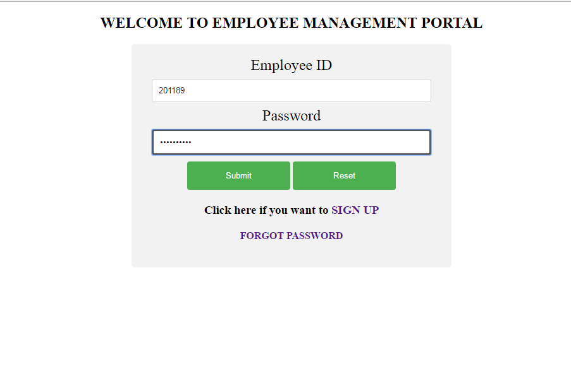

*Figure 9.1. Home Screen*

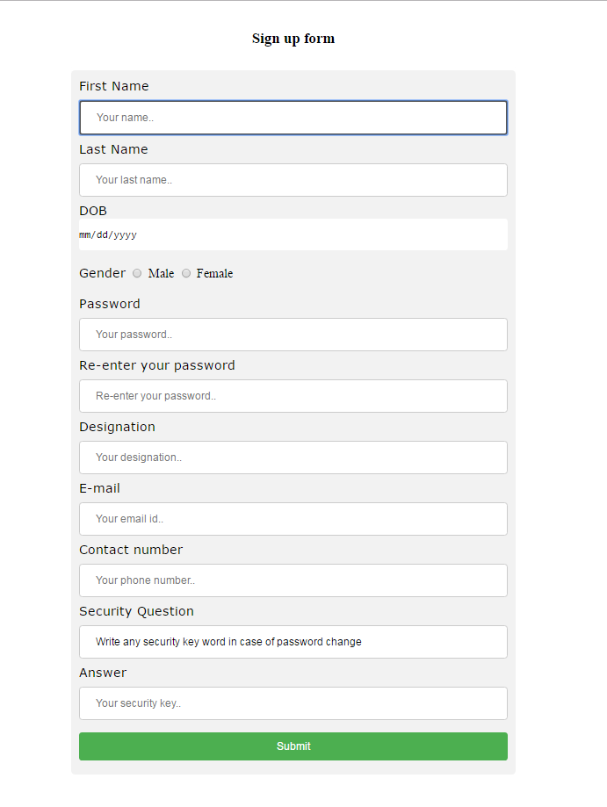

*Figure 9.2. Sign up screen*



*Figure 9.3 Home Screen*

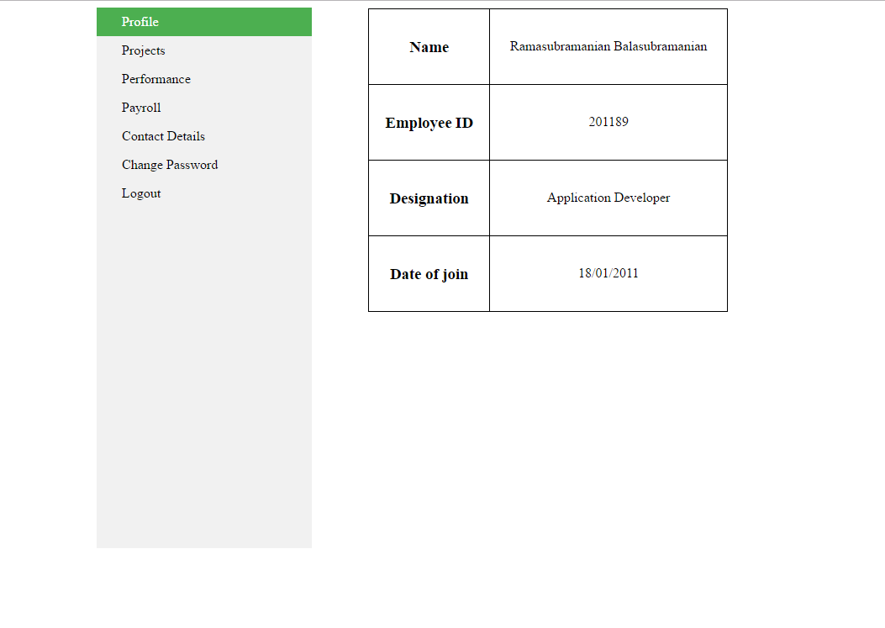

*Figure 9.4 Profile tab*

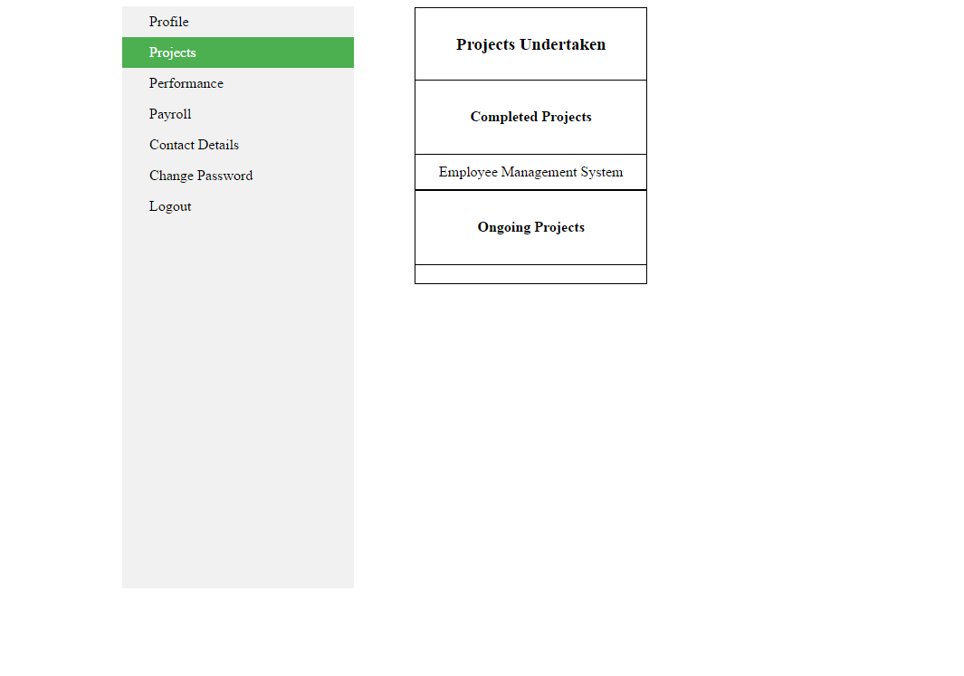

*Figure :9.5Projects tab*

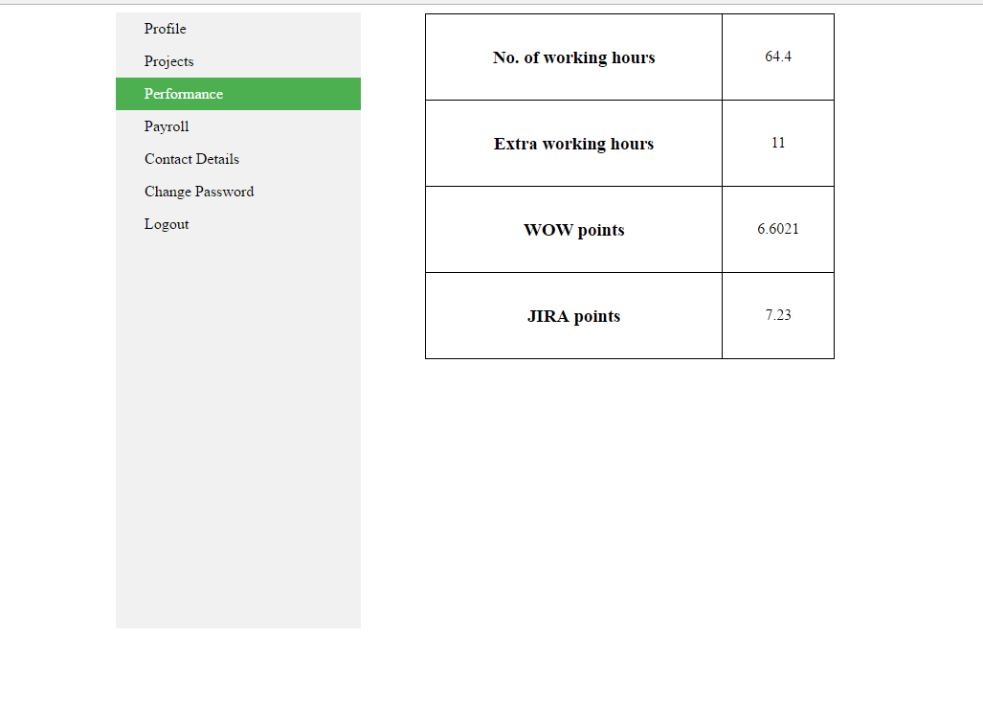

*Figure 9.6 Performance tab*

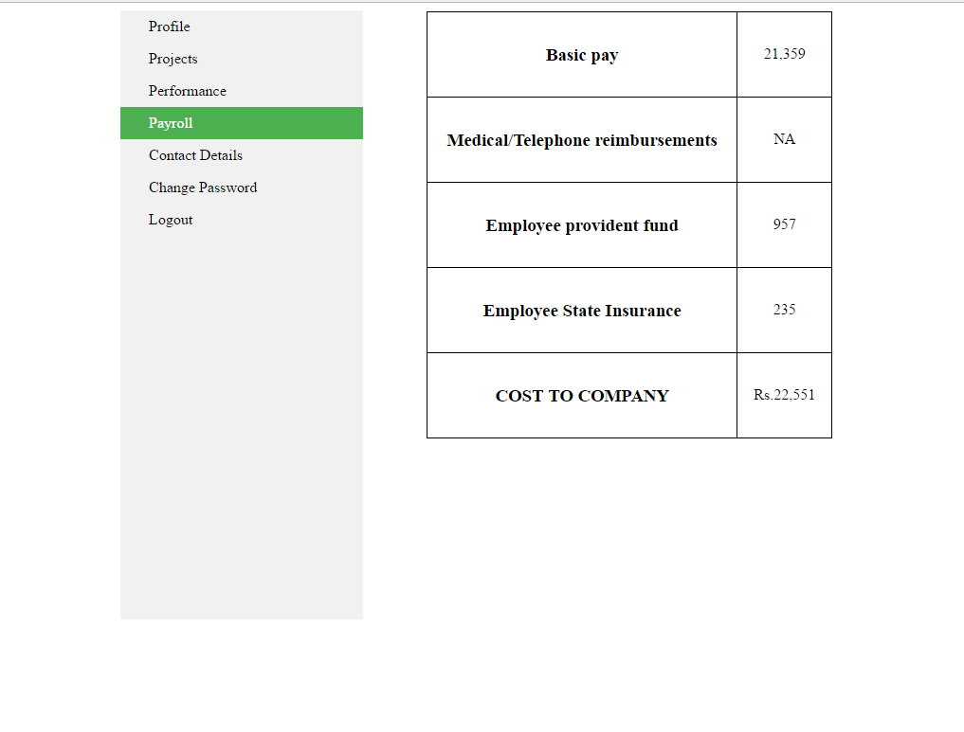

*Figure 9.6.Payroll Tab*

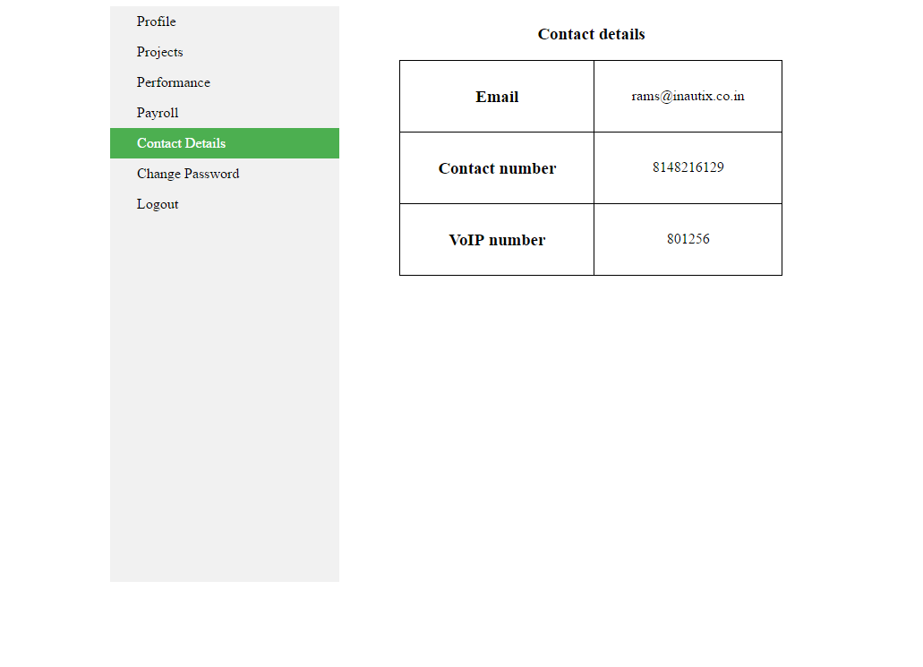

*Figure 9.7.Contact details tab*

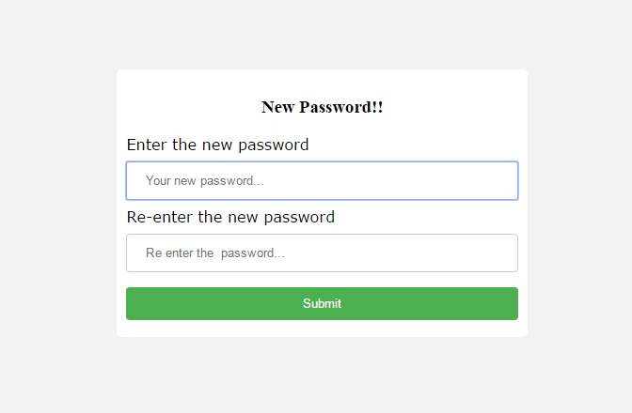

*Figure 9.8.Change Password tab*

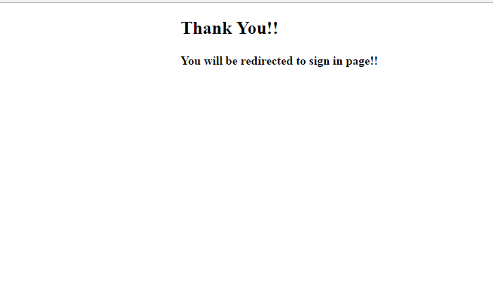

*Figure 9.9. Logout page*



*Figure 9.10. Home Screen*

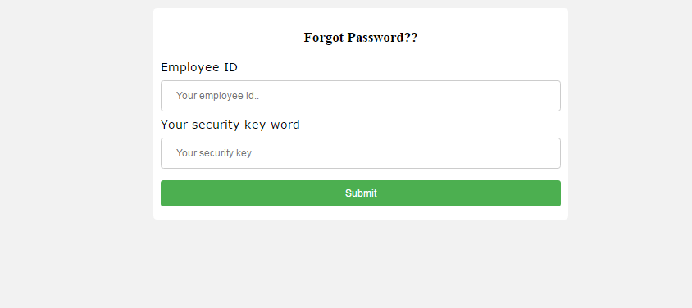

*Figure 9.11.Forgot Password*

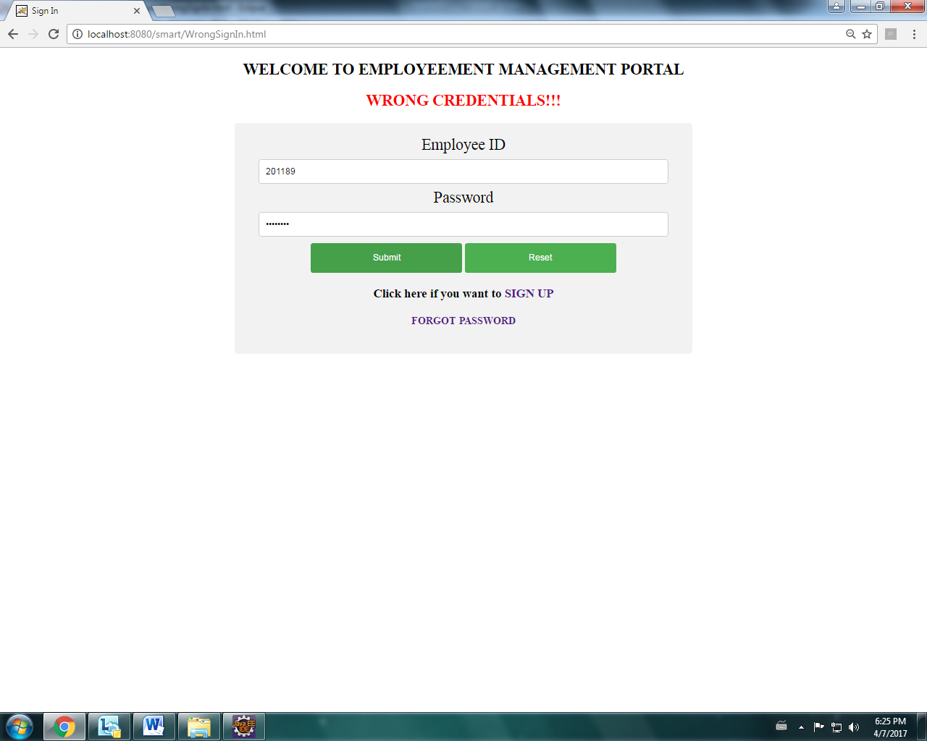

*Figure 9.12 Alert message*

10.Steps to create Spring JDBC Template:

1.Create a table with a valid tablename and required columns using My Sql,Oracle etc.

2.Create a bean class which consists of getter and settor methods

3.Create a DataAccessObject class which consists of jdbc Template along with the requried methods

Example:

import org.springframework.jdbc.core.JdbcTemplate;

import java.sql.DataSource;

private DataSource datasource;

Private jdbcTemplate jdbcTemplateObject;

Public void setDatasource(Datasource datasource)

{

this.datasource=datasource;

this.jdbcTemplate=jdbcTemplate(DataSource datasource);

}

4.The **DriverManager DataSource** is used to contain the information about the database such as driver class name, connnection URL, username and password. Hence the applicationcontext.html must be updated with bean through setter injection or constructor injection.

Example:

<bean id="ds" **class**="org.springframework.jdbc.datasource.DriverManagerDataSource">

<property name="driverClassName" value="DriverName" />

<property name="url" value="Hostaddress" />

<property name="username" value="username" />

<property name="password" value="password" />

</bean>

<bean id="jdbcTemplate" **class**="org.springframework.jdbc.core.JdbcTemplate">

<property name="dataSource" ref="ds"></property>

</bean>

<bean id="edao" **class**="com.javatpoint.EmployeeDao">

<property name="jdbcTemplate" ref="jdbcTemplate"></property>

</bean>

</beans>

5.Create main class in which it gets the bean from the application.html and calls the methods present in the DataAccessObject class.

**10.1Steps to create an Application using Spring ModelViewController(MVC):**

1. Download all the jar files for spring including core, web, aop, mvc, j2ee, remoting, oxm, jdbc, orm etc.
2. Create a bean class which consists of getter and settor methods
3. Create a controller class using Annotations

Examples of annotations:

[**1.@RestController**](mailto:1.@RestController)**:**

It is a stereotype annotation that combines @ResponseBody and @Controller and it gives more meaning to the controller class

[**2.@ResponseBody**](mailto:2.@ResponseBody)

Annotation that indicates a method return value should be bound to the web response body.

[**3.@RequestBOdy**](mailto:3.@RequestBOdy)

It is a annotation indicating a method parameter should be bound to body of the web request. Body of the request is passed through an HTTPMessageConverter to resolve the method argument and also depends on the type of the request .

[**4.@RequestMapping**](mailto:4.@RequestMapping)

Annotation for mapping web request onto the particular handler classes and handler methods. It provides a consistent style between the servlet and prolet environments with the semantics adapting to the environment.

@RequestMapping(value=”/a proper url”,method=get/put/post/delete)

[**5.@AutoWired**](mailto:5.@AutoWired)

It Marks a constructor field, setter method or config method as to be autowired by Spring's dependency injection facilities

4. Update the pom.xml with groupid and artifact id;

5. Configure the springservlet.xml as follows:

<context: component-scan base-package="package name" />

    <mvc:annotation-driven />

**<!-- JSON Support -->**

    <beanname="viewResolver" class="org.springframework.web.servlet.view.BeanNameViewResolver"/>

    <beanname="jsonTemplate" class="org.springframework.web.servlet.view.json.MappingJackson2JsonView"/></beans>

**11.Advance Rest Controller Tool:**

The only REST client that makes connection directly on socket giving full **control** over the connection and request/response headers.

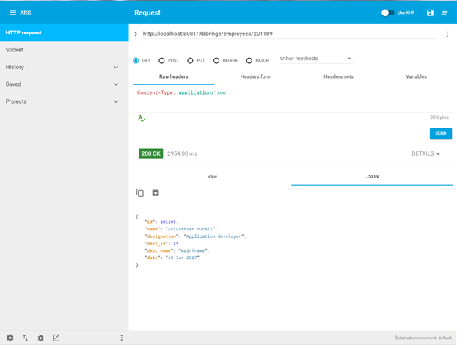

The above figure is the screen of Advance rest controller tool through which we can insert ,update delete and retrieve the records from the database.

1.It consists a section to provide the url and have to provide with the url mentioned in the main code

2.It has two bodies

1.RequestBody

2.ResponseBody

3.It provides with the methods in the form of radio buttons like get,put,delete,post.

The aim of creating an application using Restful API web services is to make it loosely coupled and all the java objects will be changed to JSON Objects.

**11.1 Advance Rest Controller for POST Method**

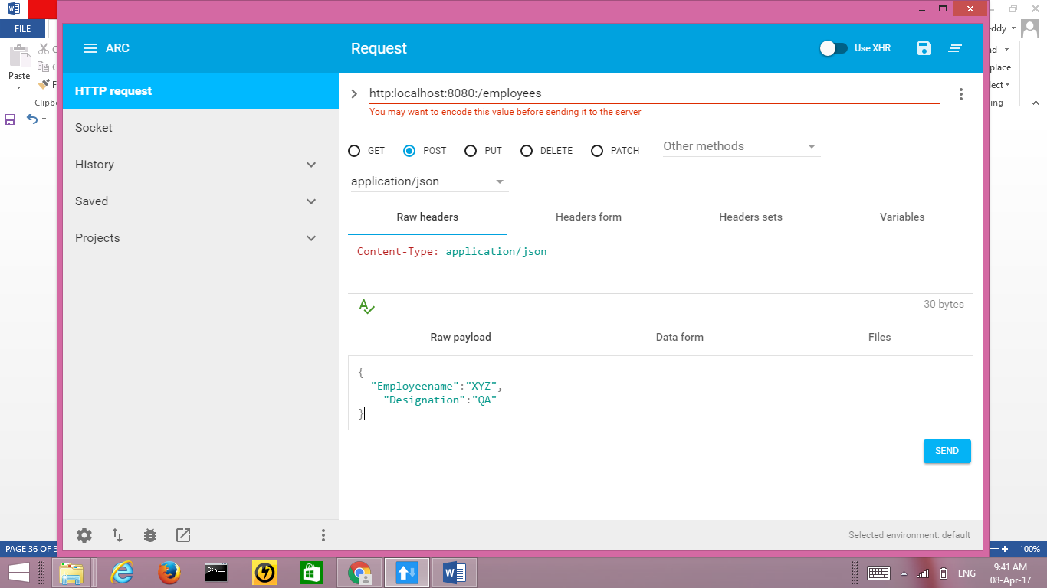

**11.2 Advance Rest Controller for PUT Method**

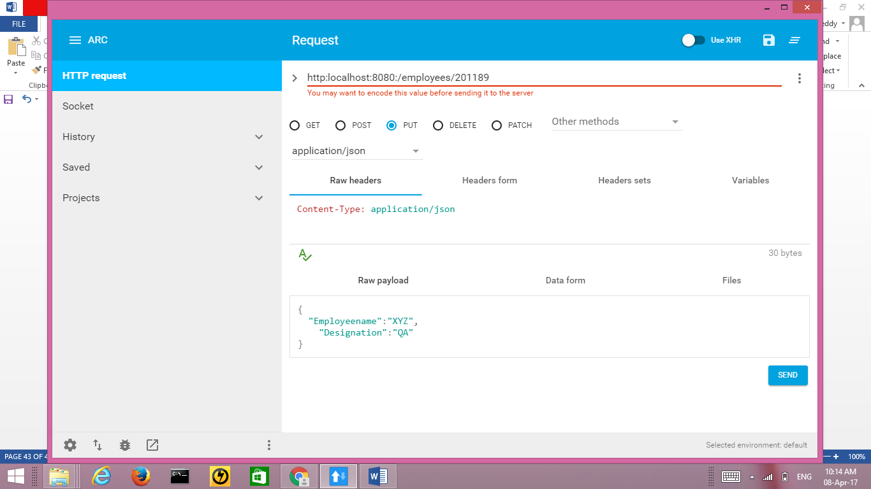

**12. CONCLUSION**

The application developed has been subjected to various tests and measures that include factors to view all the details of an employee like his projects,profile,payroll details etc. This application needs to be further integrated with the Application which updates the working hours of an employee using RHD scanner and it also to be integrated with production region . Integration is being done by adding a new tabs in the application using spring framework. A special thanks to the all the faculty members for their cooperation in successfully producing the project report.

**13. REFERENCES**

* <https://www.w3schools.com/html/>
* <https://www.tutorialspoint.com/maven/>
* <https://www.w3schools.com/css/>
* <http://www.javatpoint.com/jsp-tutorial>
* http://www.javatpoint.com/spring-tutorial